Project Design Phase-II
Technology Stack (Architecture & Stack)

Date | 6 June 2025
Team ID | LTVIP2025TMID38618
Project Name | Revolutionizing Liver Care : Predicting Liver Cirrhosis using Advanced Machine Learning Techniques
Maximum Marks | 4 Marks

Technical Architecture:
The Deliverable shall include the architectural diagram as below and the information as per the Components & Technologies & Application Characteristics

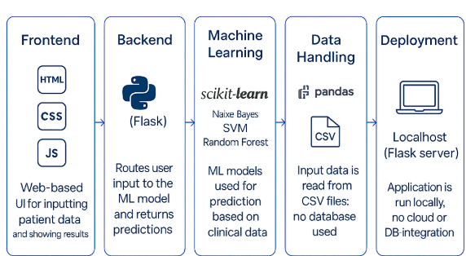

Table-1 : Components & Technologies:
S.No | Component | Description | Technology
 | User Interface | Web interface for clinicians to input data and view predictions | HTML, CSS, JavaScript
 | Application Logic-1 | Data preprocessing and handling missing/categorical values | Python (pandas, NumPy)
 | Application Logic-2 | Model training, prediction, and evaluation | Python (scikit-learn)
 | Application Logic-3 | Flask-based integration to link frontend and backend | Python (Flask)
 | File Storage | Store model files and datasets locally or in GitHub repo | Local Filesystem
 | Machine Learning Model | Predicts whether a patient has liver cirrhosis | Naive Bayes, SVM, Random Forest,Logistic regression,
 | Infrastructure (Server / Cloud) | Application runs locally using Flask; can be extended to cloud | Local (Flask server)

Table-2: Application Characteristics:
S.No | Characteristics | Description | Technology
 | Open-Source Frameworks | Frameworks and libraries used for development | Flask, scikit-learn, pandas
 | Security Implementations | Application is local; data privacy ensured through offline processing | Local-only use; no cloud auth
 | Scalable Architecture | Can be scaled using microservices or hosted on cloud in future | Flask + Modular Python files
 | Performance | Optimized with preprocessed data and saved models for fast predictions | Flask,pandas

